Urine Sample
To avoid contamination wash your hands before starting. Don’t let the end of the pipette touch anything other than your urine and don’t put the pipette down after opening it. Please choose the yellow tube which is labelled and says “Urine” for this sample.

Instructions:
- Please ensure it has been more than 1 hour since you last passed urine.
- The first part of your pee should be collected in the white top urine container.
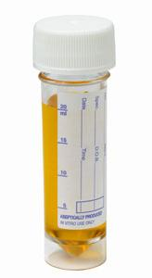
- Take the disposable pipette and transfer urine from the above container into the small yellow urine specimen tube so that the level of fluid is between the two black marked lines.

- Put the top back on the tube tightly and make sure you don’t spill any of the liquid inside.
- Place the sample in the blue microbiology bag and seal it. If you are doing more than one sample please use the separate bag provided for each.
- Wash your hands.
- We have included a small results card which has a sticker with your clinic number starting ‘AN’ and your date of birth. Please hold onto this. It has the results line number printed along the top that you need to call in 1 week time. When you call please ignore the ‘AN’ and just put in the 8 digit number and your date of birth when requested on the phone.
- If any results are positive we will organise treatment for you.
- Please hand the sample(s) in to your GP practice.

